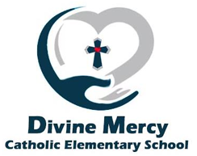
Divine Mercy Catholic Elementary School Council Meeting – Minutes
2840 Duncairn Drive, Mississauga, ON L5M 5C6

January 13, 2025, 5:30 pm | Meeting called to order by Sandra Viola

Staff/School Representatives:
Sandra Viola (Principal)
Daniela Letterio (Teacher Representative)
Pamela Leermakers (Community Member)

Parent Representatives:
Angela Trewartha (Co-chair) | Elaine Dantas (Parish rep) | Paula Mendonca*
Tannice Ashman (Co-chair) | Deanna Catania* | Esther Dolapo Ogunjobi
Tashani Parker (Secretary) | Jessica Clayton* | Katrina Vieira Reis
Michelle Ferreira (Treasurer) | Vivian Correa-Pinto* | Jonathan Walker*
Sarah Carson (OAPCE rep) | Lisa Bitonti-Bengert*

Parent Regrets:
Pearl Mofunanya*
*=voting members

- Routine Matters
  - Call to Order and Attendance
  - Opening Prayer
  - Land Acknowledgement
  - Approval of Agenda
    - Approved by Daniela Letteri and Jessica
  - Approval of Catholic School Council Minutes (November 24, 2024)
    - Approved by Deanna and Michelle
    - Business Arising from the Minutes

- Trustee Update
  - Brea Corbet sends her regrets

- Standing Items
  - Chair’s Report
    - Tannice attended two meetings for the executive council
      - The first meeting was the intro and seeing who was going to hold different positions
      - The second meeting- had community engagement and discussed what items they wanted to engage in. The meeting was held in person, and different ideas were shared, but the board didn’t e-mail the list of ideas, and although a copy was requested, she hasn’t received anything
      - Next meeting February 13, 2025
    - Angela
      - Pizza
        - Last 4 weeks of pizza- pay for the next sessions will occur last week of January
        - Federal GST rebate impact- saving money from December 15 to February 15- approximately $70-$75 each week?
        - ACTION: Need volunteers on Tuesdays to help distribute pizza
        - ACTION: Angela is looking into pricing for pizza places for next year- maybe looking at another location potentially
      - Subway
        - Tashani will prep notice to be sent for the second session later this week

  - Treasure’s report
    - December closing balance shared
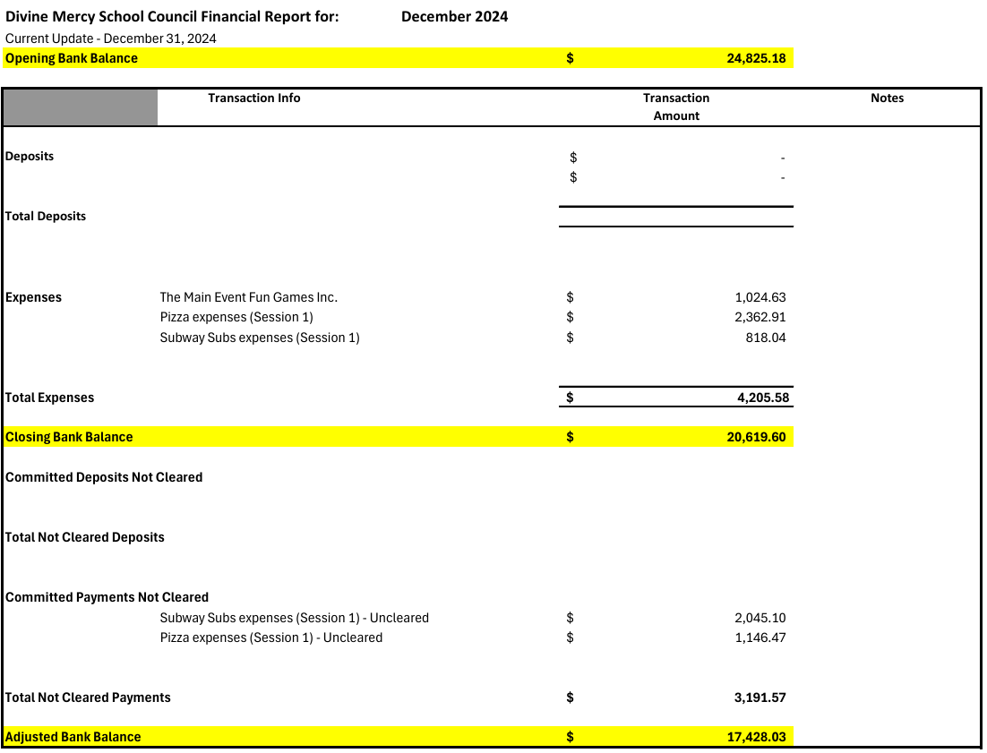
    - Approved budget for 2024-2025 by Tannice and Lisa Bitonti-Bengert
      - Chromebooks cost removed
      - Pizza fundraiser is going very well
        - Still have 4 more weeks to pay for pizza
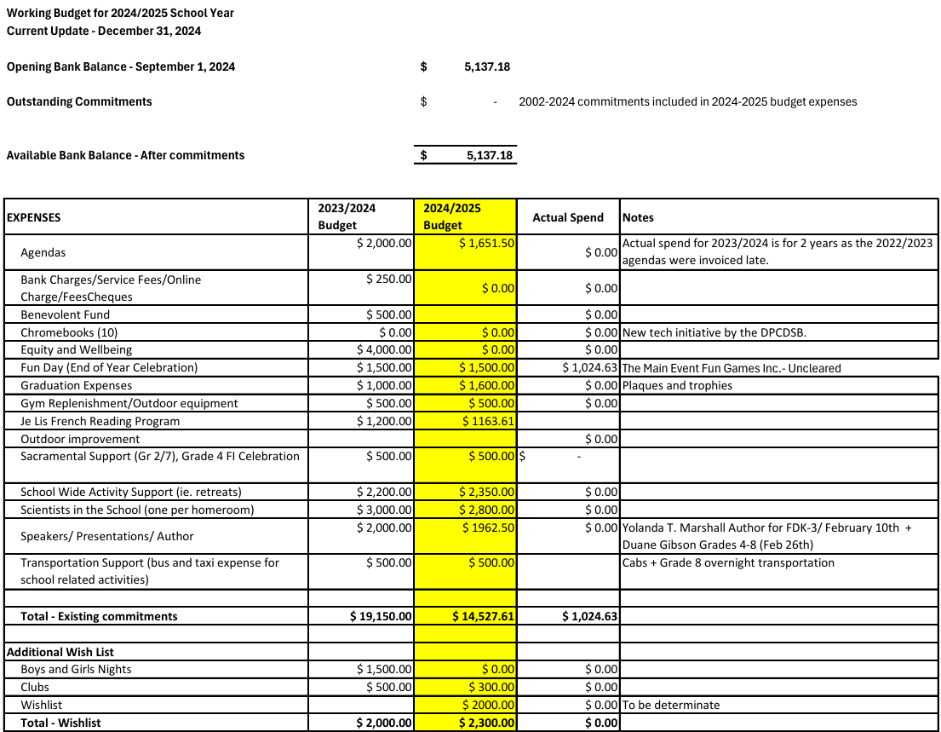
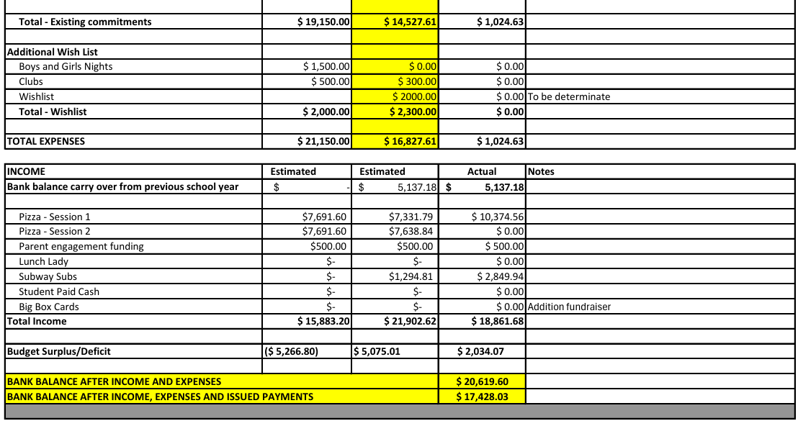

  - Principal Report
    - Catholic Faith life:
      - Father Seamus will be visiting our grade 7’s tomorrow and they will be visiting the church next Wednesday to learn about the parts of the mass and more specifically the significance of each.
      - the second First Communion virtual meeting for parents will take place on January 20th .
      - Staff continue participating in the Employee Sharelife Campaign through the Board/ initiatives for Sharelife at our school/ Spirit Day and Raffle at Staff meeting to raise funds etc.
      - Christmas initiative/ Wellbrook Place directors were extremely grateful for the Christmas cards for the seniors.
      - Generous donations of food and toys assisted families in our school community, families in neighboring communities. SW Danish Sheikh assisted in delivery of food and toys.

    - Health and Well-being:
      - ‘Press Pause Mondays’ continues which introduces a mental well-being strategy provided by School Mental Health Ontario/ School Support Team involved
      - Wellness walls/calming corners built into classes and front foyer (visuals)/ Build resilience
      - Brave Education presentations took place in primary classrooms last Thursday. The response/ feedback from teachers was overwhelmingly positive and kids were very engaged and responsive/Walk away, talk away and block away-responding confidently and kindly and standing up for yourself in a positive way
      - Further workshops will be booked for Juniors on Bullying, Conflict and Relationships (Healthy Boundaries)
      - New workshop in Spring for parents/caregivers on ‘Understanding Mental Health’-Ms.Viola to look into opportunity.
      - Bell Let’s Talk Day- January 22nd/ School wide initiative in morning to continue promoting further conversations and awareness about mental health and actions built on care and access and research.

    - Equity:
      - Principal spoke with Christoff- founder of Flight Unit
        - Workshops focused on leadership, dynamics of communication
        - Has many workshops- equity and allyship, adjusting new norms- focused more on the inclusive lens and equity- so will follow up with to determine most applicable organization going forward based on needs of the school
      - In speaking with the Acting Coordinator of the Board Equity Department- Madd Skillz was suggested
        - The program content provides connections to the school curriculum by engaging in more skills-based learning workshops with an aim to make learning more inclusive and meaningful for students of all backgrounds and abilities
        - ACTION: The principal will look into both (Flight Unit and Madd Skillz) and then book either one into the new year
      - Black History Month
        - Focus on uplifting and identifying success stories and achievements of Black-identifying Canadians
        - The Department of Equitable and Inclusive Education offers opportunities for classes for virtual read alouds that help address the importance of representation, building inclusive spaces and pride in identity. The most recent read aloud offered is with Rabia Khokar.
        - We will have Yolanda T Marshall visit our school- she’s an award-winning, Caribbean-Canadian author of 20 diverse, inclusive and festive children's picture books, will be visiting our school and presenting/ “Hot Cross Buns for Everyone,” which is about Jackson, whose friends wanted to bring their best hot cross buns (eg Italian, Greek, Scottish and Jamaican Easter buns) to his Easter Party. The entire community is coming to join and form new friends!/ “My Soca Birthday Party” too, where Anne’s friends celebrated her day with the music and African/Caribbean foods she loves.
        - We’ll also have Duane Gibson visit our school; he’s a Canadian-born rapper, author and motivational speaker whose message will center around being driven and his overall success story.
        - I want to continue doing my best to support equity and well-being initiatives. I will continue discussions with the Board Equity department as well as the focus groups here to get an update and idea of where we need to go next.
      - Mme Costanzo and Ms. Symonds continue to be our Catholic equity leads who also continue being involved in equity efforts to build capacity in our school.

    - Achievement:
      - Use of High impact instructional practices continue/observations of lessons- collaborative learning opportunities/ partners and/or groups and focus on descriptive feedback, rich math conversations and direct instruction.
        - Going into class this week to observe math lessons
          - Observations this week- looking for collaborative tasks, and lend themselves to rich math conversations- between teacher and student, between students- and descriptive feedback
      - Differentiation of instruction, accommodations and smaller guided group sessions continue when and where needed
      - Board promotion of CPF and their opportunities and resources, provided that these are in alignment with our school board policies. 2024-2025 Concours d’Art Oratoire: DPCDSB has registered for the Concours d’Art Oratoire 2024-2025 offered by Canadian Parents for French (Ontario). This opportunity allows students in grades 4-12 to demonstrate their French oral language skills (optional for students).
      - Currently, the Council has supported the Je Lis Program for our FI students which is also a wonderful resource.
        - Spoke with French Immersion teachers- Je Lis program is in use, and they feel comfortable with the resources they are using
        - Principal did discuss with the board to support covering the cost
      - EQAO/ math is currently in French- question brought forward to math consultant - if math for EQAO can be done in English for French Immersion students

    - Upcoming dates/General updates:
      - Discuss fundraisers for next year, 2025-2026
        - Think of an additional smaller fundraiser for next year, that can be completed on a smaller scale, but we should start thinking about what this looks like now
        - Yearbook- spoke with someone about the yearbook- maybe next year through Edge imaging
          - They provide a license and agreement to use and provide access to a yearbook specialist to assist the team
          - Lowest economic option- 20 pages, additional pages extra; stapled version $15.57- perfect bind book 34 pages; 48 pages in total- $22
          - If the school has a yearbook, it will be run by parents, with 1 teacher for support;
            - Parents running it will need a consent form to share with parents at the end of the year- parents would pay the cost for the yearbook on their own and share if they are interested in getting a yearbook
      - Parent question- Does the board have math or language tutors?
        - Response: will ask around and inform parents of options, suggestions were shared by other parents regarding different private platforms where individuals offer their services
      - Shrove Tuesday
        - If you have any griddles or are able to support by volunteering- your help is welcomed!
      - Tech refresh plan
        - Removed cost from parent council budget, because there is a central process at the board
      - Monday, January 20th- PA Day for Assessing and Reporting
      - Wednesday, January 29th: Dental Screenings for JK, SK and grade 2
      - Thursday, January 3oth: Grad Photos
      - Friday, January 31st: Term 2 begins
      - BLACK HISTORY MONTH: All classes will be involved with initiatives
      - February 17th: Family Day
      - February 10-14th: Spirit week/Friendship week/ Report Cards sent home/ Book Fair/ Interviews
      - February 25th: Fete Francophonie
      - March 4th: Shrove Tuesday
      - March 5th: Ash Wednesday

  - Parish Report- Elaine
    - Jan 20 virtual parent meeting streaming online
    - Confirmation (Grade 7)
      - Jane starting to meet this week with parents
    - EDGE- grade 6-8
      - Free biweekly program
      - Runs Fridays from 6-8 pm in the church basement hall
        - Speaks about catholic faith
      - The registration link is on the Merciful Redeemer website
    - Santo Nino Mass Jan 18 @ 9am
      - Can bring statues of infant Jesus to be blessed
    - Alpha- Mondays 7-9 pm from Jan 20- April 28
      - Video series with reflection and discussion so one can learn about the core principles of Christianity and address some of life’s “big questions”.
      - Light refreshments will be provided. If you are interested in joining the program, please email Flo at mrpeaceandblessings@gmail.com
    - First Communion:
      - Visit the YouTube channel at www.youtube.com/@MercifulRedeemerParish/ streams on January 20th for a virtual parent meeting at 7 PM. Contact jane@ mercifulredeemer.org with any questions or concerns
      - First Confession (Parent and Child): Wednesday, February 26th, from 4-6:30 pm

- Information/Updates
  - Central Committee for Catholic School Councils (CCCSC) Report
  - Ontario Association of Parents in Catholic Education (OAPCE) Reports- Sarah
    - Attended several meetings
    - Fall in-person representative meetings across regions and training
    - OAPCE advocates, and is an organization that is independent of the board and mandated to exist by the government- has directors from the board and representatives from school councils
    - Purpose- have each school connect to a larger network and give parents insights to advocate to the board if needed and direct inquiries and pass on information about upcoming surveys
      - Example- survey on cell phone ban and vaping policies
    - Conference in Dufferin-Peel this spring- speaker and resources they can introduce to parents

- Action Items
  - Budget updates/review and approval of updated budget
  - Further fundraising ideas
    - Movie night- maybe April
    - Market night
  - French Immersion Intake
    - Waitlist, has about 8 or 9 students, at this time, there is only one grade 1 class for 2025-2026
  - Does the school want donations?
  - Annual declaration if no change in vulnerable sector check results is normally shared mid-march

- Future Meetings
  - Monday, February 24, 2025
  - Monday, April 7, 2025
  - Monday, May 26, 2025/In-person and potluck meeting

- Adjournment at 6:44 pm
  - Next meeting: Monday, February 24, 2025 at 5:30 pm

