
Divine Mercy Catholic Elementary School Council Meeting – Minutes
2840 Duncairn Drive, Mississauga, ON L5M 5C6

May 26, 2025, 5:30 pm | Meeting called to order by Sandra Viola

Staff/School Representatives:
Sandra Viola (Principal)
Daniela Letterio (Teacher Representative)
Pamela Leermakers (Community Member)
Brea Corbett (Trustee ward 9 and 10)

Parent Representatives:
Angela Trewartha (Co-chair) | Sarah Carson (OAPCE rep) | Jessica Clayton*
Tannice Ashman (Co-chair) | Elaine Dantas (Parish rep) | Vivian Correa-Pinto*
Tashani Parker (Secretary) | Paula Mendonca* | Johnson Lai
Michelle Ferreira (Treasurer) | Deanna Catania* | Katrina Reis

Parent Regrets:
Jonathan Walker* | Lisa Bitonti-Bengert* | Pearl Mofunanya*
*=voting members

- Routine Matters
  - Call to Order and Attendance
  - Opening Prayer
  - Land Acknowledgement
  - Approval of Agenda
    - Approved by Elaine and Michelle
  - Approval of Catholic School Council Minutes (February 2025)
    - Approved by Johnson and Jessica
    - Business Arising from the Minutes

- Trustee Update
  - Thanked the Principal and the committee for their support of the council and leadership at the school
  - Board meetings every Tuesday night at the board office
    - Tomorrow night, core education funding will be reviewed- the meeting is posted online and can be accessed from YouTube
      - Funding is based on a per-pupil basis
      - Transportation and special education, device upgrade and maintenance are underfunded by the government
      - Operating under a multi-year financial recovery plan
  - Brea has 16 schools, west of Erin Mills and North of Eglinton
  - Parent Question: Funding for chaplains?
    - Response: Chaplain will exist, but will look different, have chaplains that are teachers and non-teachers- will continue to have a dedicated chaplain for every secondary school and a non-teacher chaplain- current teacher chaplains were given the option to stay as teachers – help to connect between elementary and secondary school chaplain role

- Standing Items
  - Chair/Treasurer’s Report
    - Tannice attended executive council will start pilot program with vaping alarms- at 5 different high schools- St. Roch, Our Lady of Mount Carmel, Robert F. Hall, Ascension of Our Lord, St. Martin- with minimal funding from the ministry- the alarm will go off in the office and staff will be notified
      - Reason- concern: students do not feel safe going into the washroom, inappropriate use of washrooms, vaping, and bullying
      - Goal- not just to detect vaping, but will detect identifiable words such as help, won’t detect words like
      - Response-
    - Peel Police presentation
      - Presentation on May 29 didn’t occur, there was one at the end of April- 3 hours long- suggestion maybe to have it on a Saturday
      - Education on vaping, human trafficking - 2nd session for Mississauga occurring
      - Sent out from the board, reshared within schools, shared on the trustee's social media, and posted on the DPCDSB website
    - Pizza
      - Winding up pizza- thank you to the volunteers for their help and the grade 8s
      - Thank you to everyone who organized and helped with movie night; it was great
    - Shout-out to people leaving
      - Tashani, Paula (moving to another school) and Pam, who is retiring

  - Treasure’s report
    - April budget is reconciled
      - Spent a little more money on speakers and presentations
    - May is preliminary- however, there are still items to be paid out/reconciled
      - Pizza is still to come out
      - Wanting to earmark for the 2026 school year
        - Earmark- want to buy 10 Chromebooks with a cart- $4,000
          - With tech refresh program, kids- JK-4 4-1, grade 6- 2-1, 7-12: 1-1
        - The makerspace room- robotics $800
      - Schools are allowed to carry over some budget for items earmarked
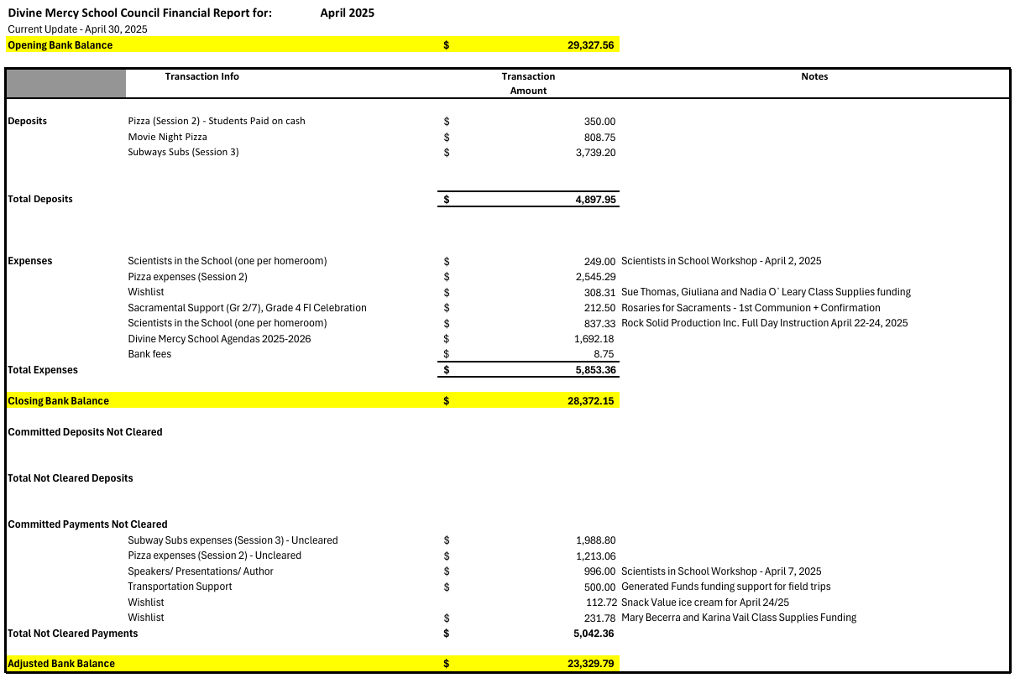

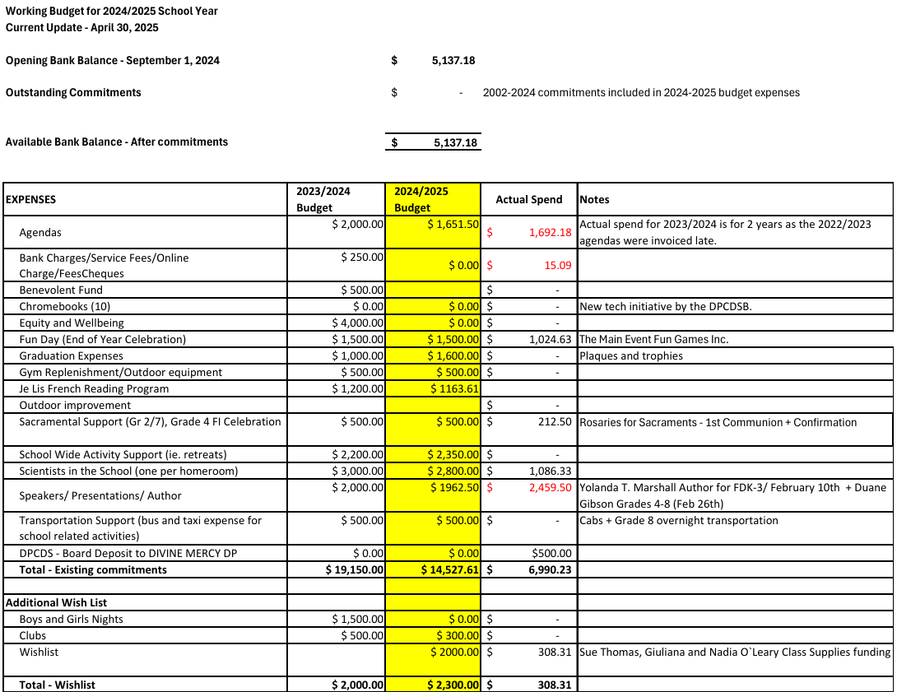
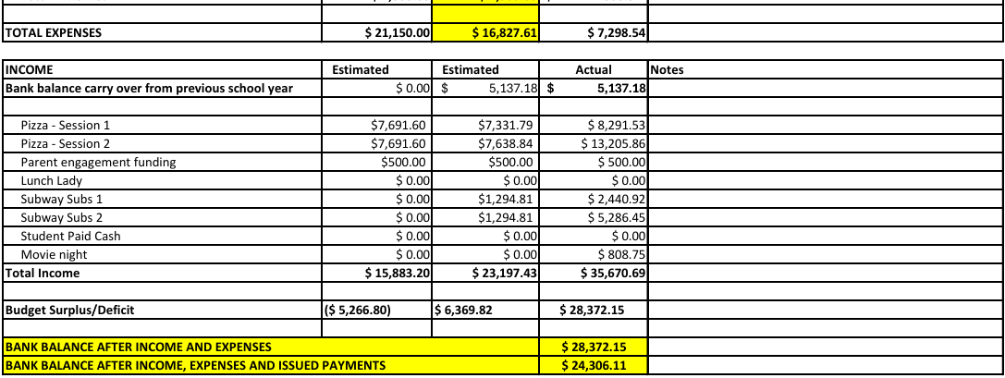

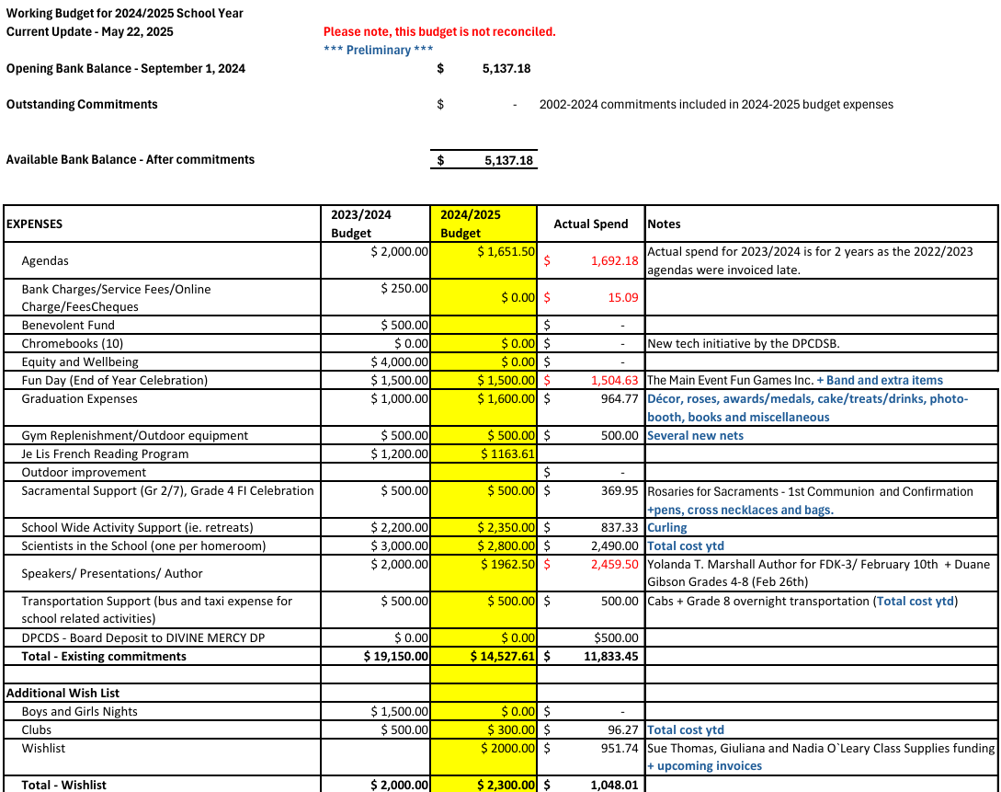
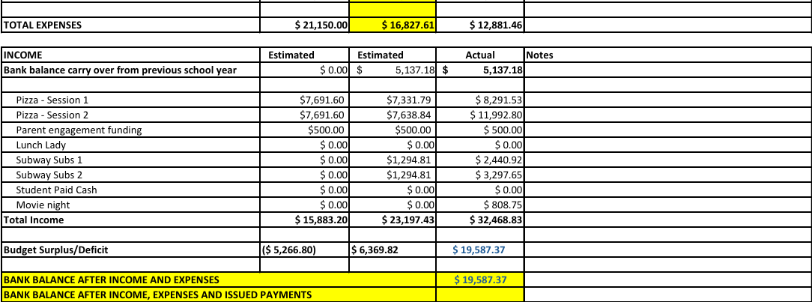

- Principal Report
    - Catholic Faith life:
      - The Lenten season began on March 5th
        - A variety of activities celebrated in class each week (Lenten liturgies, class reflections, Lenten journals/morning announcements reflected the importance of deeper prayer, fasting and almsgiving during Lent)
        - The focus of the school was on acts of charity
          - Donations of soap were given to Dr. Simone, and Sharelife donations received.
          - Thank you to the committee who supported with initiatives- collected a lot of soap and money for Share Life with pretzels, Christmas cards, toy collection, and gift giving
        - Shrove Tuesday meal on March 4th was successfully run by Mrs. O’Leary and the grade 8s and parent volunteers.
        - March 5th, we were joined by Father John, who joined us for our Ash Wednesday liturgy, and Mrs. Symonds' class led our Holy Thursday liturgy.
      - Partnership with Morningstar rosary will continue/Marian celebration was a special time, and students were excited about being a part of this special celebration of our Blessed Mother
      - Grade 2’s communion was celebrated on May 25, and Grade 7 confirmation was celebrated on May 7
        - Gifts on behalf of the Catholic School Council were received, and students were extremely appreciative.
      - Wellness Day incorporated a special story in the afternoon titled ‘You, Me, We, A Celebration of Peace and Community’ where students had post activities around peace pledges in their school community

    - Health and Well-being:
      - Thank you to the staff who run teams and clubs to support wellness and engagement
        - Eden Food- good collaboration for helping
      - Brave education workshops are booked for next year, Building Emotional Regulation will continue next year: K-3; Setting Healthy Boundaries 4-6; Grade 7 and 8, Understanding Stress
      - THRIVE resource in newsletters and Peel e-blasts informs parents of important information for wellness
      - Eco initiatives have taken place- waste audits, book swaps, The great gulp and Big Crunch- Divine Mercy will receive gold status
        - Bike to school is coming
      - Continue to refer to SMHO resources and post in classes/ continue to train Mental Health Leaders, and gain more participants
      - Whole school success wellness day retreat was a success
        - Thanks to Peel Nurse, Support staff, Mental Health leaders and Grade 7 and Grade 8 leaders leading activities.
          - Focus was on individual growth for wellness, and connection of mind, body and spirit.
      - Movie Night was a success
        - Community engagement that fosters positivity and the well-being of the community
      - Positive feedback received about the girls' group club
      - Rocks and Rings/ team sports continue

    - Equity:
      - Continue to build on an inclusive curriculum-diversity in voices, cultures, and histories, so all students feel represented
      - Continue to center student voices to share their perspectives and experiences, especially from underrepresented
      - Continue to engage staff in professional development on inclusive practices and anti-racism
      - Continue to use harmful language interrupters in class, rooted in anti-racist practices, but used towards all oppressive behaviour/ all students require a common language
        - Last staff meeting- had a session on common knowledge of common language for grades 4-8- giving them language to express if they’re feeling oppressed and unsafe- helping them to explain themselves, and having it up in the classroom

    - Achievement:
      - EQAO- students were exposed to practice work and EQAO sample tests
        - Grade 3’s are finished, grade 6’s- will complete next week
        - Consensus of French Immersion (FI) administrators throughout the Board is that Math continues in French
      - Grade 4’s FI students have had transition meetings with OLOM
      - Had intermediate study hall- extra time to get help or finish homework
      - Classes booked a Scientist in the school- teachers appreciated the support
        - Used the Grant for experiential learning to cover costs
        - Teachers are appreciative of the $100 from the budget per class
          - Money spent on class supplies, but some teachers wanted to have celebrations with the class, like a pizza party- maybe consider it for next school year
      - Acadience screening- round 2 took place for grades K-2
      - Juniors and Intermediates were successful in the Skills competition, winning medals
      - GAUSS test for Grade 8’s/ more intriguing and challenging problems
      - Got a grant for wellness day
        - On wellness day, students received a kit that kids brought home

    - Upcoming dates/General updates:
      - May 27-29th- Grade 6 EQAO
      - June 5th- Softball tournament/ Pam’s retirement party
      - Monday, June 9th: PA Day Report Card Writing
      - June 11-13th: Brock Trip
      - Monday, June 16th: Talent Show in the afternoon
      - Wednesday, June 18th: Grade 8 graduation
      - Thursday, June 19th: End of the year BBQ
      - Friday, June 20th: Kinder Celebration of Learning/ Grade 8’s go to Mandarin and bowling/ Afternoon celebration for grade 4 FI’s and grade 8’s
      - Monday, June 23rd: Year-end Mass at the Church at 9 am
      - Tuesday, June 24th: Final report cards go home
      - Wednesday, June 25th: Co-ed beach volleyball/ whole school play day
      - Friday, June 27th: Year-end celebration at 9:30 – digital yearbook
        - Grade 4 and 8- parents are invited to clap out at 2:45 pm

    - Thanked parents for support

- Parish Report
  - Continue with the Edge program up until grade 8 on Friday evenings
  - Saturdays- for high school students- food served
  - Parish BBQ this Sunday after 12noon mass on June 8- $10- polish sausage, hamburgers, dunking the parish priest, music by DJ, ice cream truck
  - Corpus Christi procession on June 2, 2025- over 800 people last time

- Information/Updates
  - OAPCE update
    - In-person meeting a few weeks ago- nice to be part of the group, and there’s a lot of support for parents and community- wants to think about ways to showcase this more

- Action Items
  - Budget wrap-up
    - Shared above
  - Feedback on movie night/any new suggestions for next year
    - Need a permit for any events to turn the air conditioning on, as schools don’t have control over
      - From an efficiency approach, it is centrally controlled
      - Thanked everyone who dressed up, it was great
    - Think about new suggestions for next year to do something, Fall/winter, and then spring
      - Suggestion:
        - Proposing a Christmas or spring market
        - Professor Jam- end of year BBQ,
  - Team recognition
  - Further discussion of any other business
    - Suggestion: Table at the BBQ for council- Elaine, Vivian, Sarah, Angela volunteering; give out a one-pager of what the school council is and its purpose and importance, what’s been done for the year
    - Open house as well

- Adjournment at 6:40 pm

